Aldi, I'm attaching a screenshot of the sample **UDEKI** system that I sent you the access points for. Since I see that I can no longer log in, I think they've taken away my trial access.

1. The interface of the main board and the courses can be improved, with the option of comments, reactions, uploading office files, being able to edit with black letters and place emoticons, being able to select which group can view the publication such as managers, teachers, programs or courses. Having the option of filtering the publications.

Clear, its can implemented

UDEKI SYSTEM : DASHBOARD SUB-MODULE:

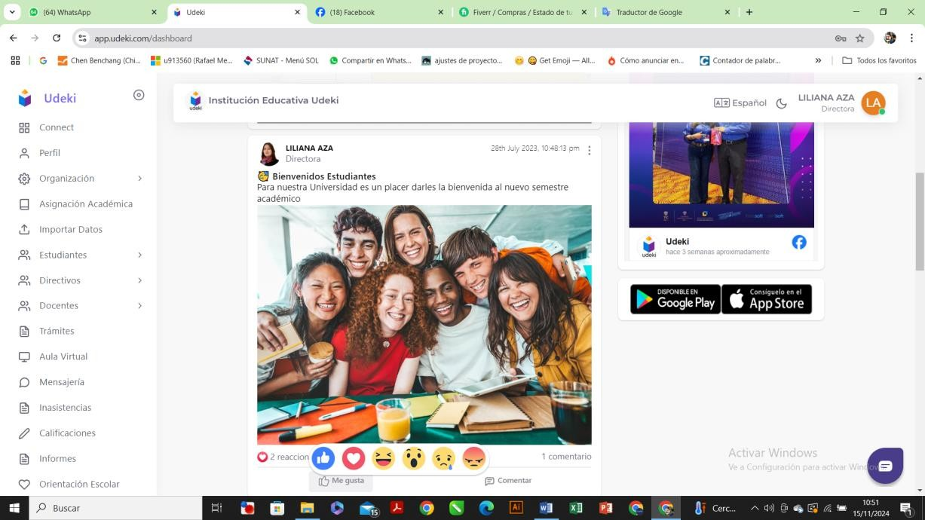

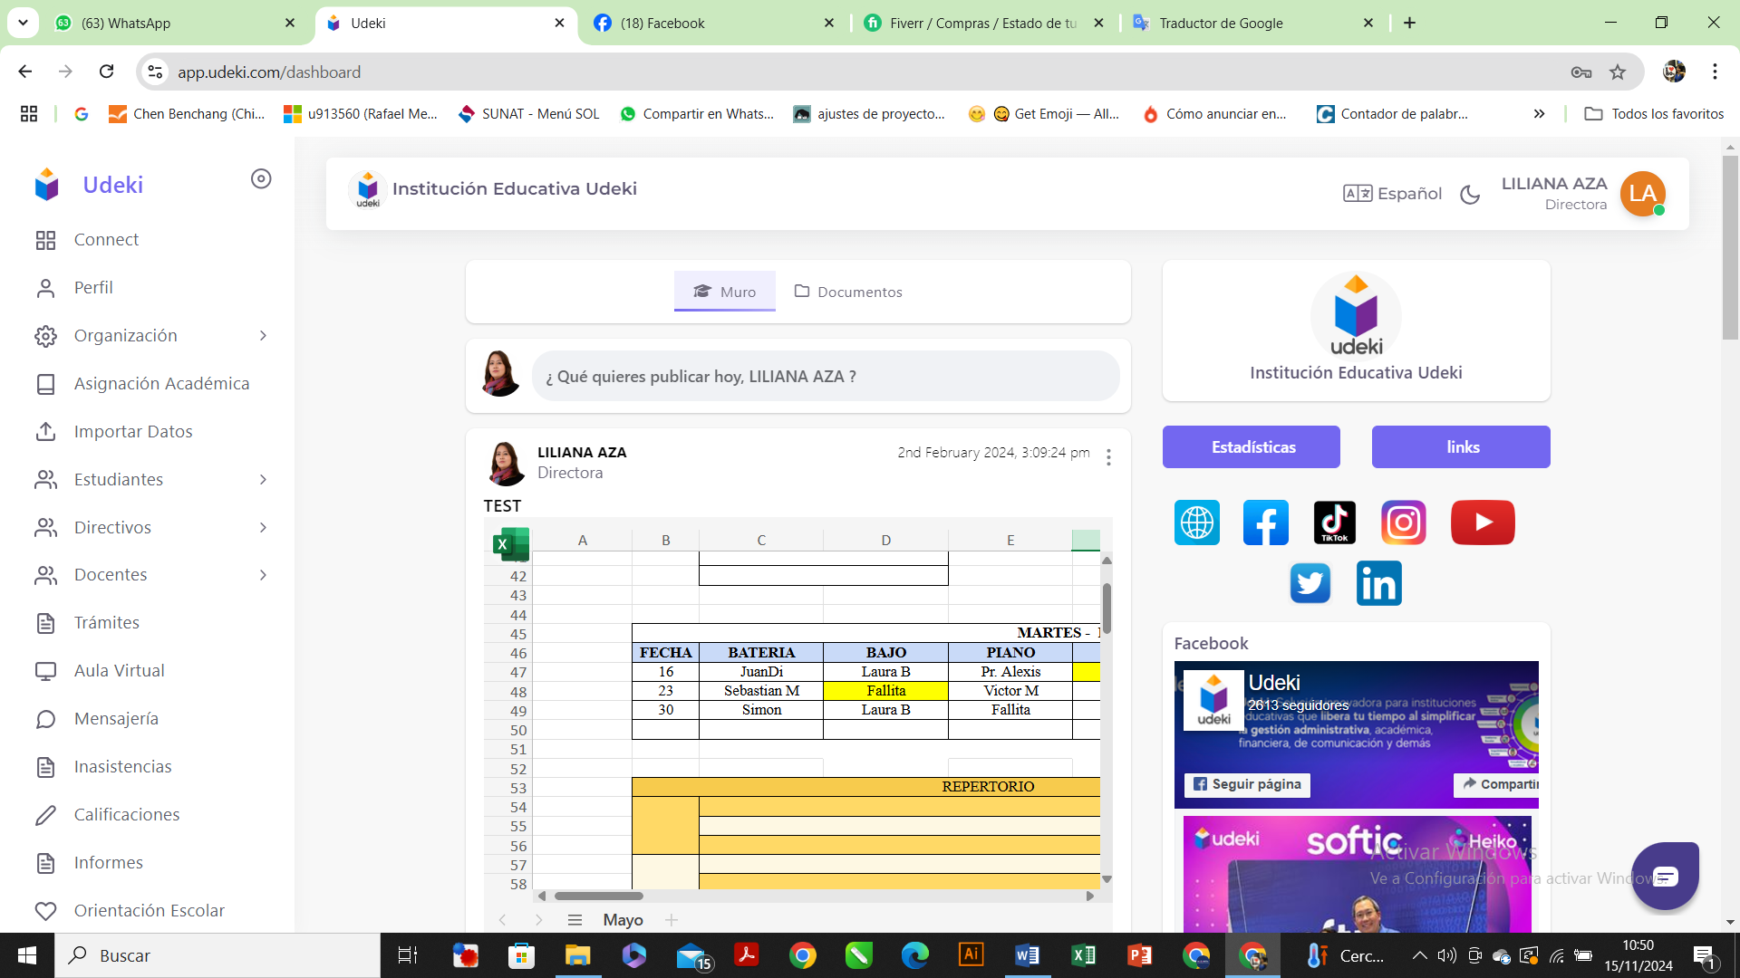

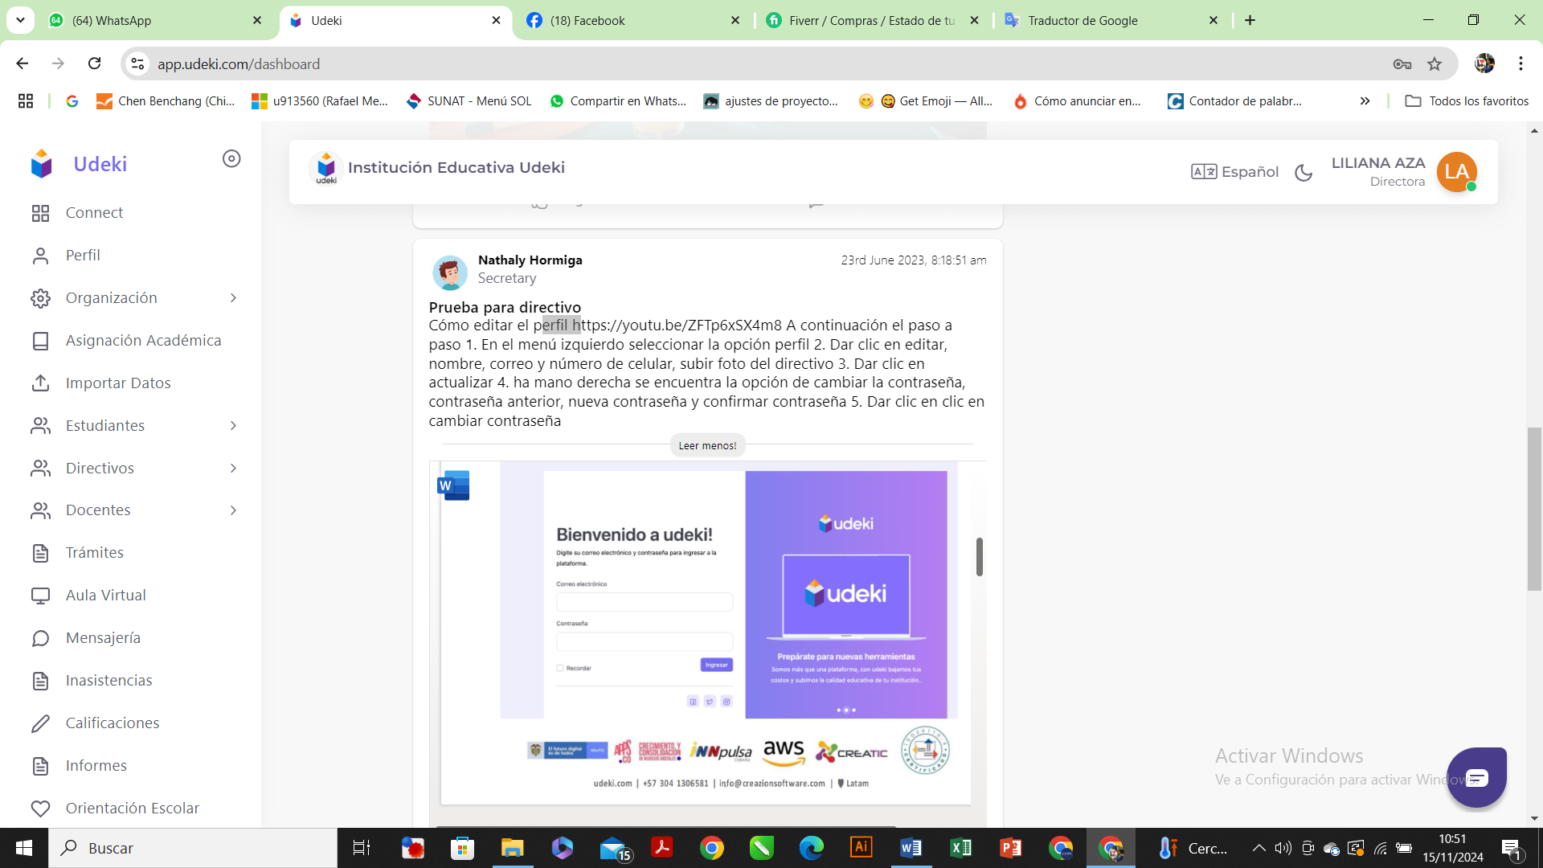

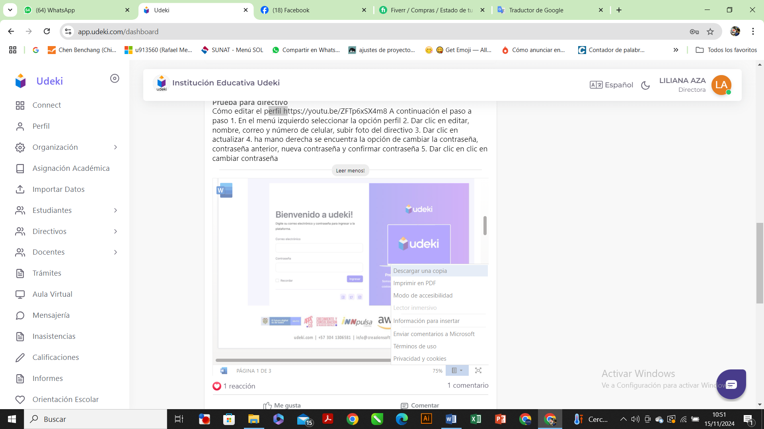

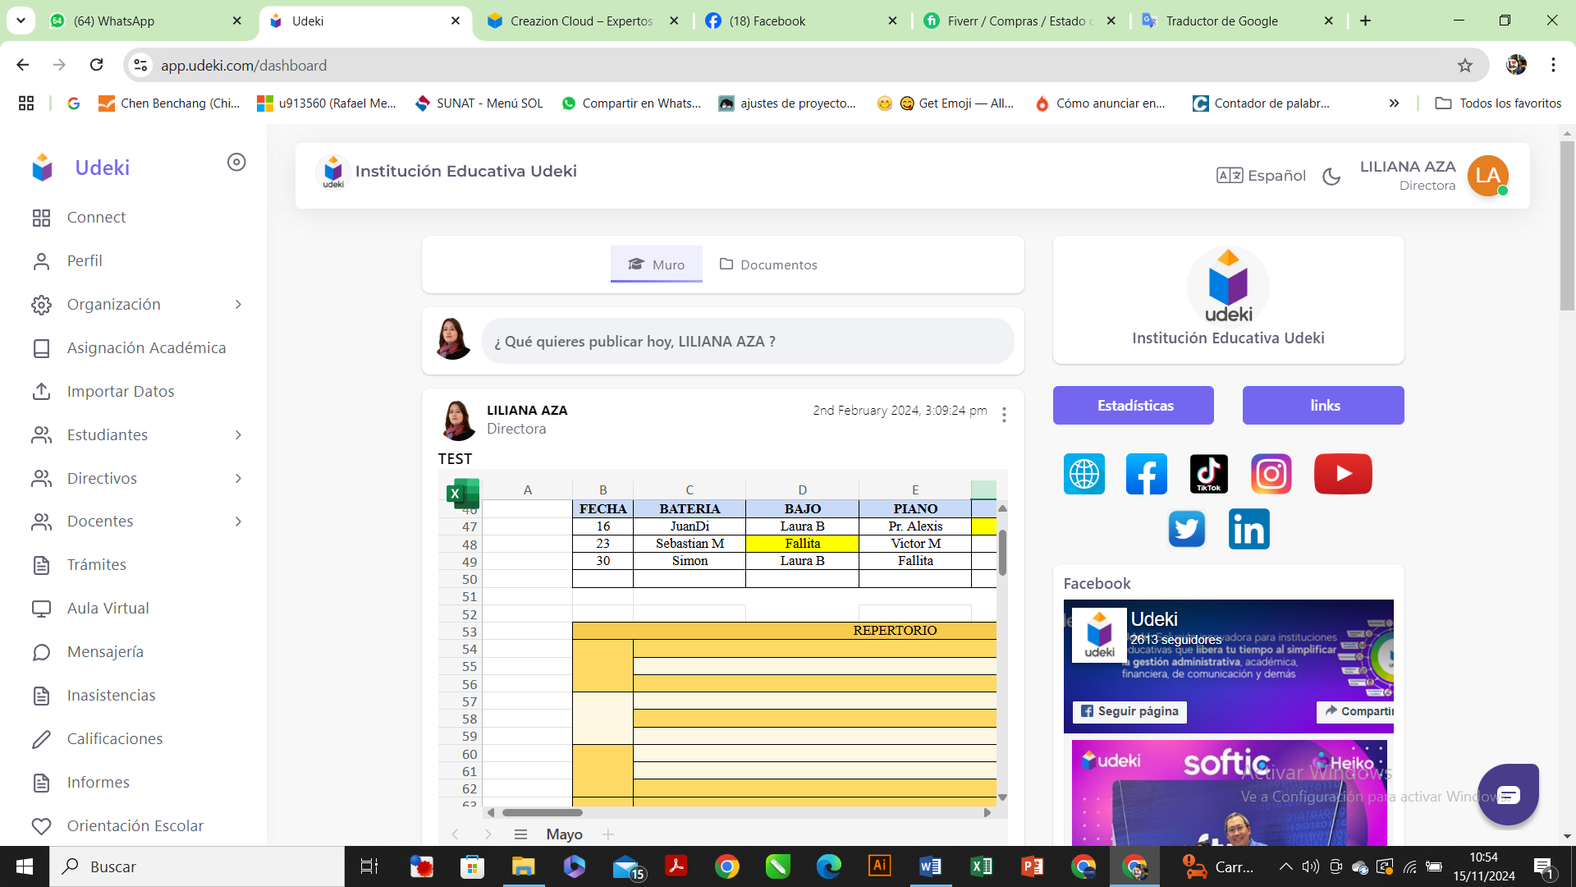

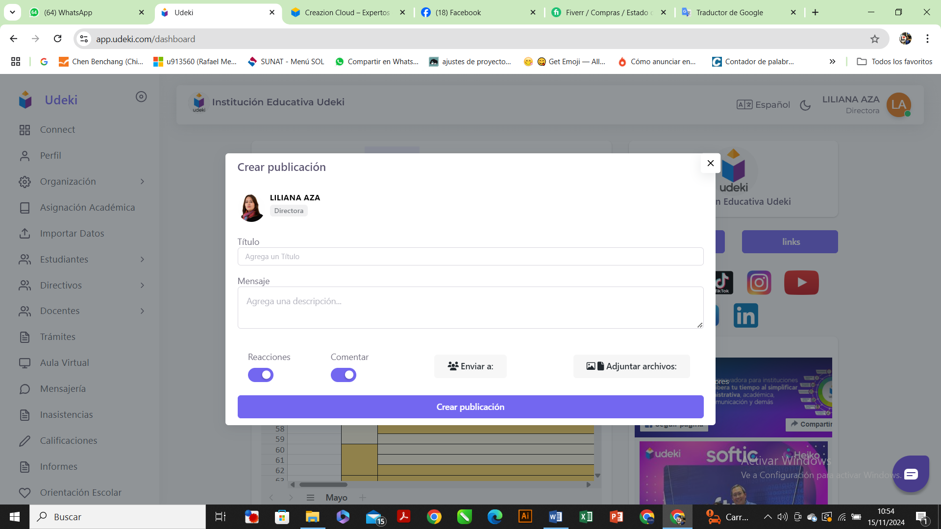

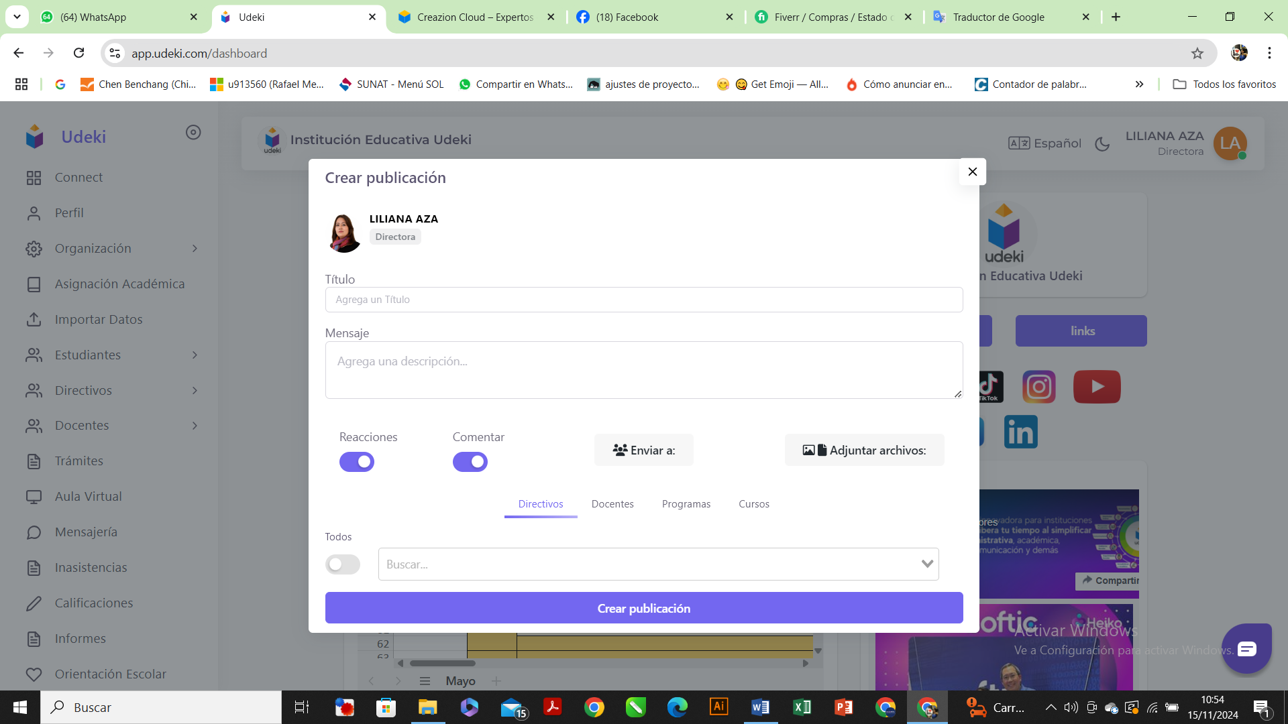

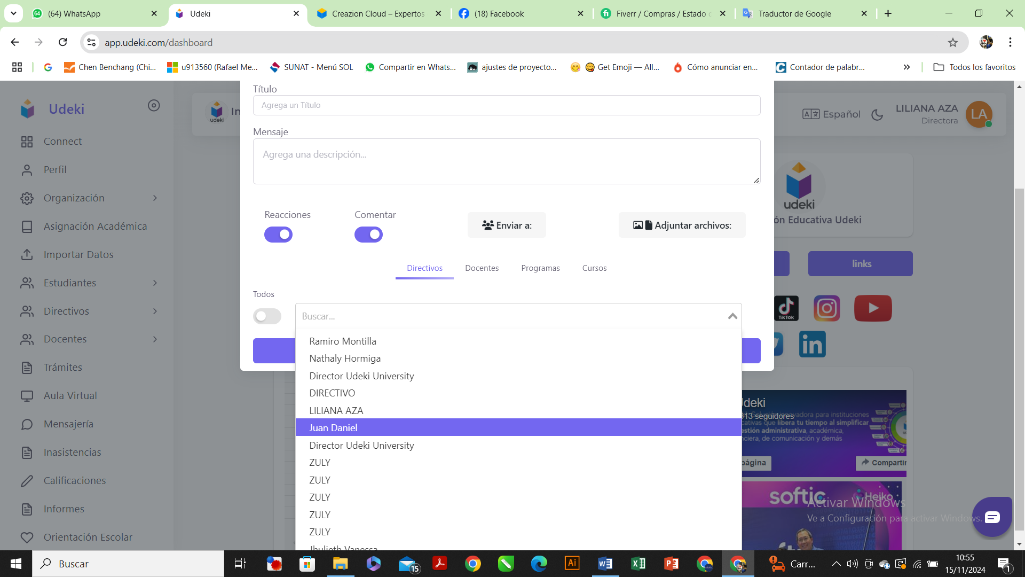

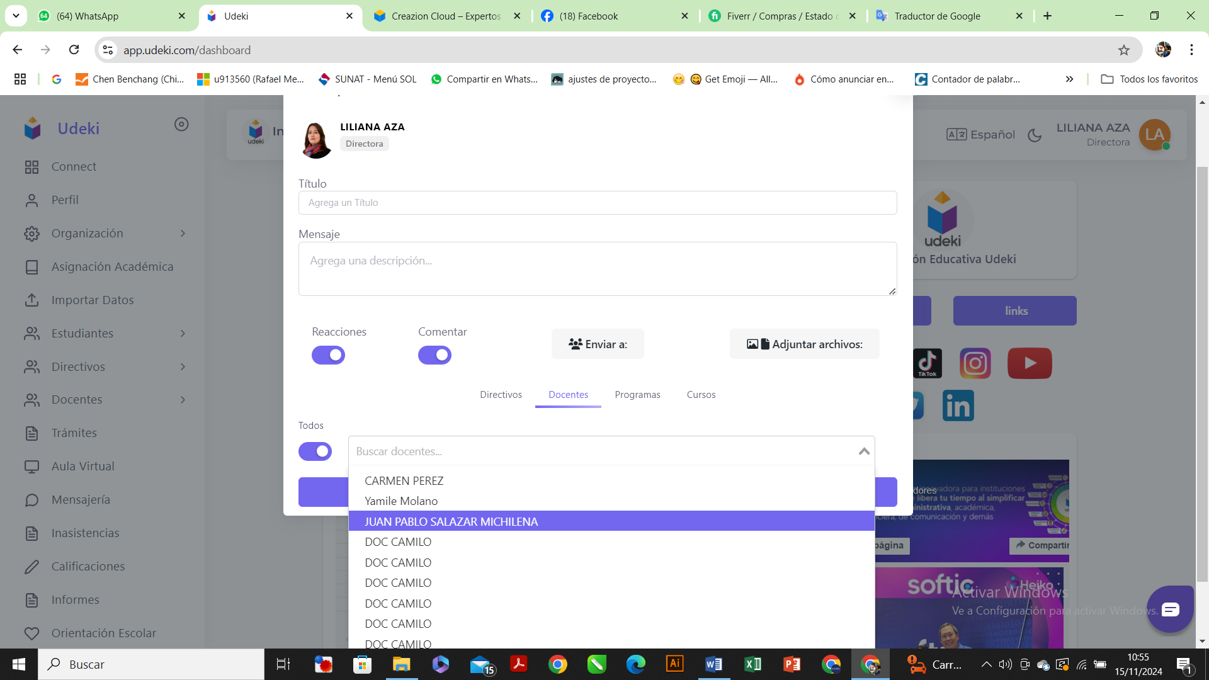

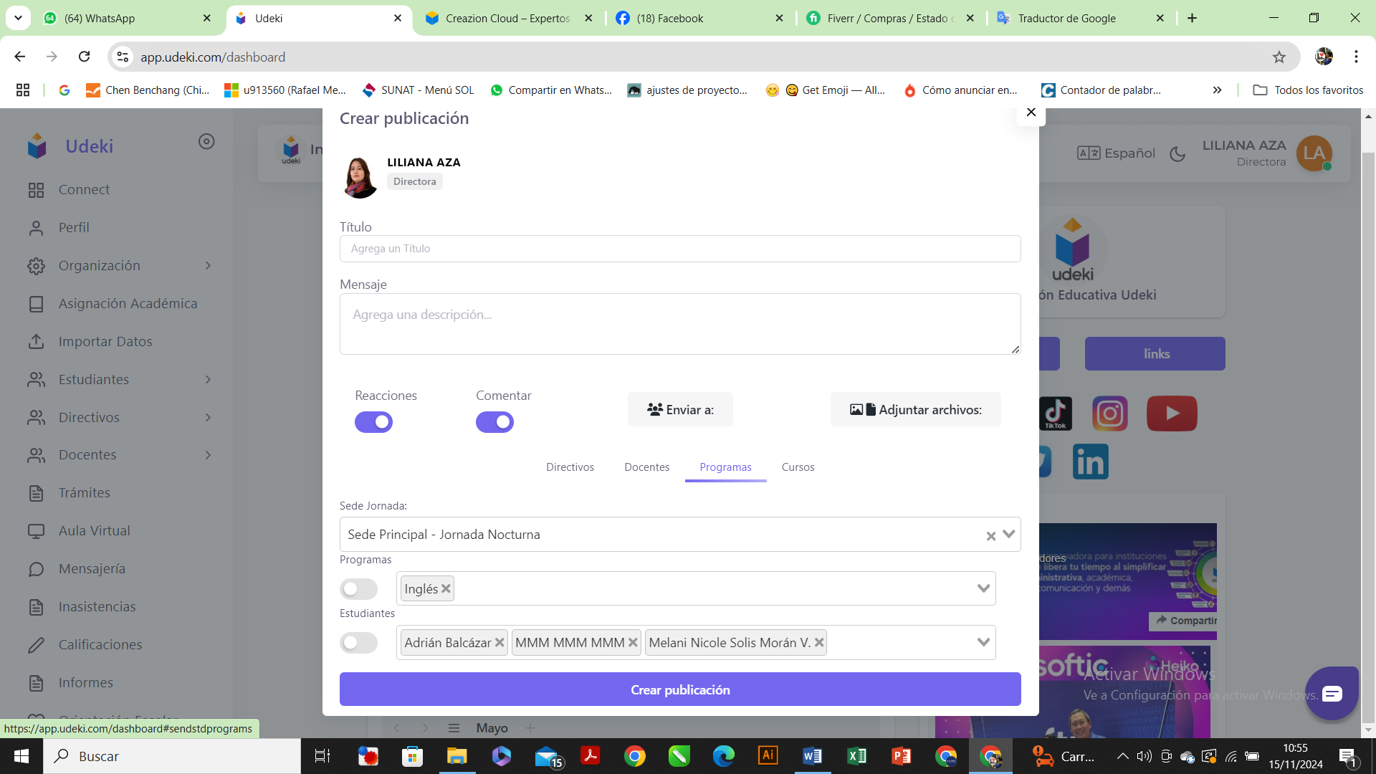

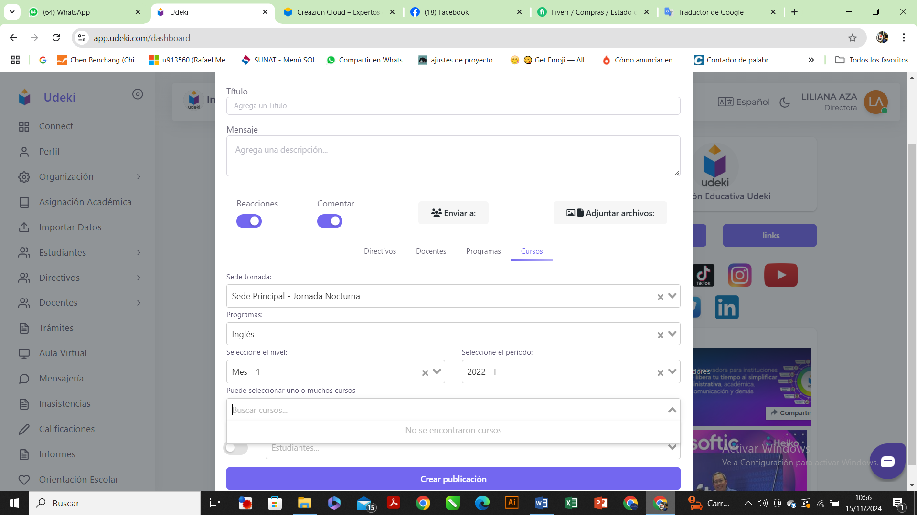

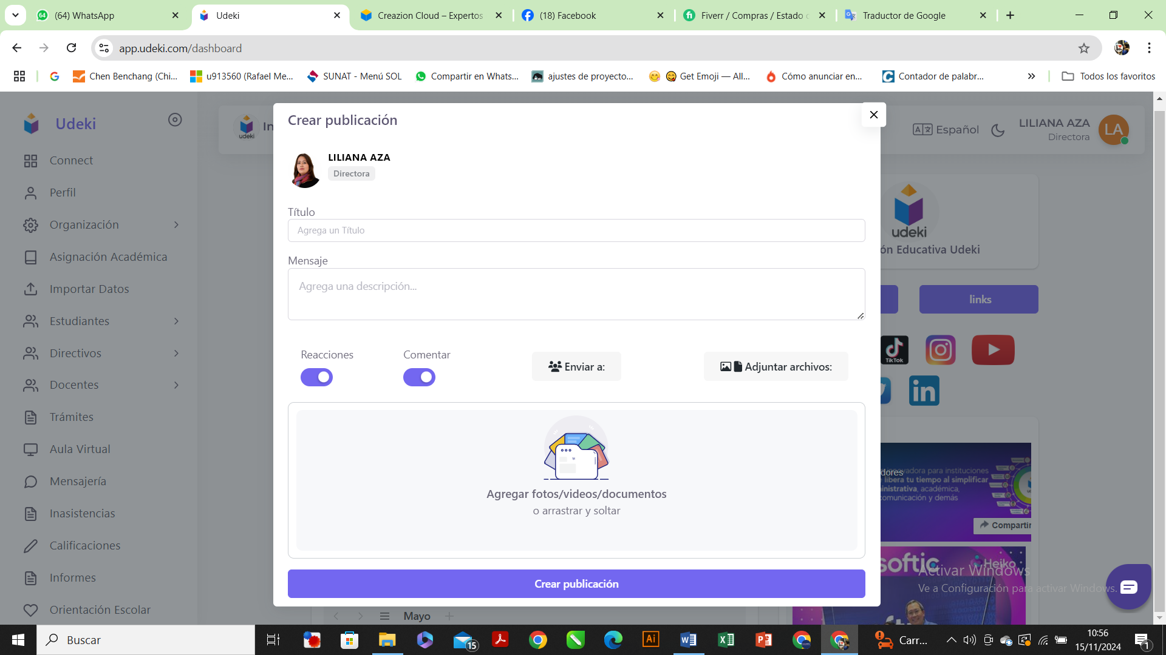

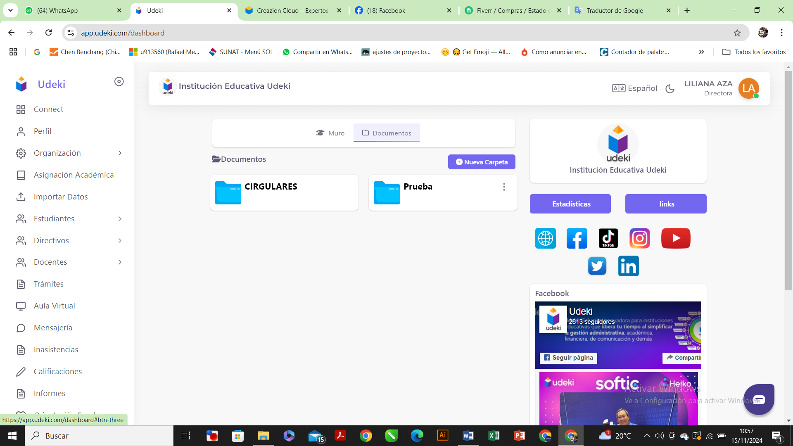

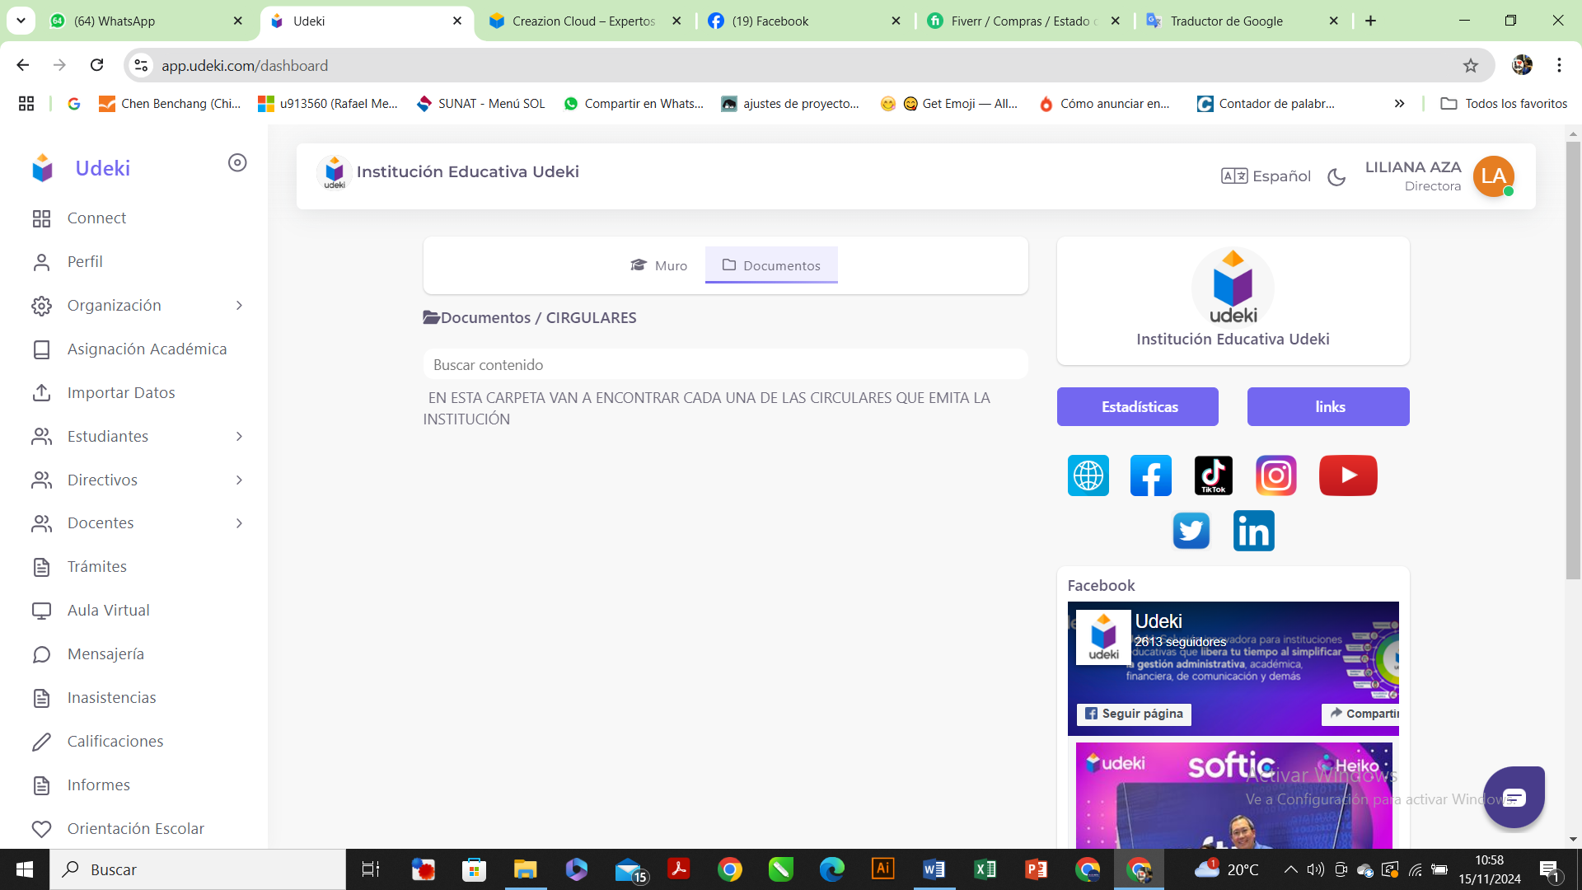

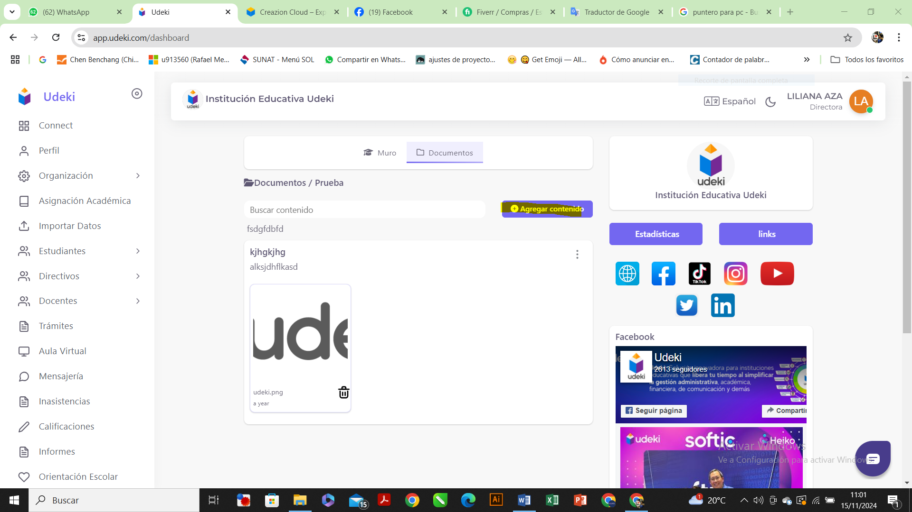

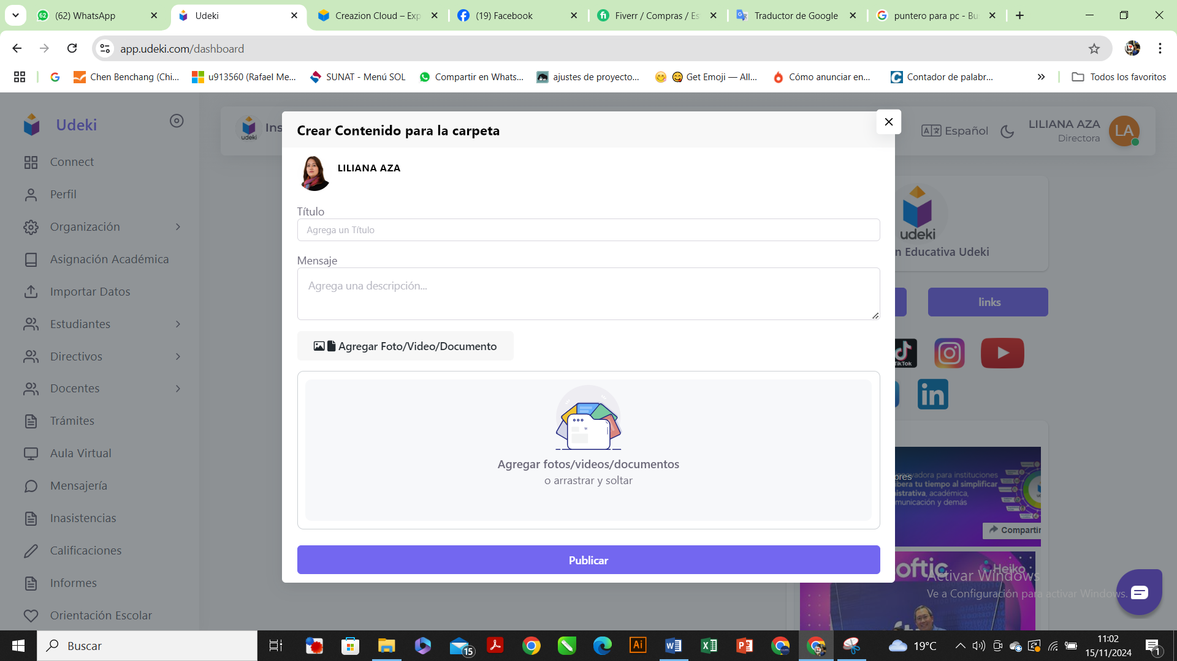

1. Have the option to create locations so that it is directly linked to the student's registration and also to sessions. This allows me to select the courses that are taught at the location in the student's registration.

Clear, its can implemented

UDEKI SYSTEM : SUB-MODULE VENUES AND CONFERENCES:

What is striped with yellow, is when you click, the following screen opens

SUB-MODULE VENUES AND CONFERENCES:

UPDATE HEADQUARTERS:

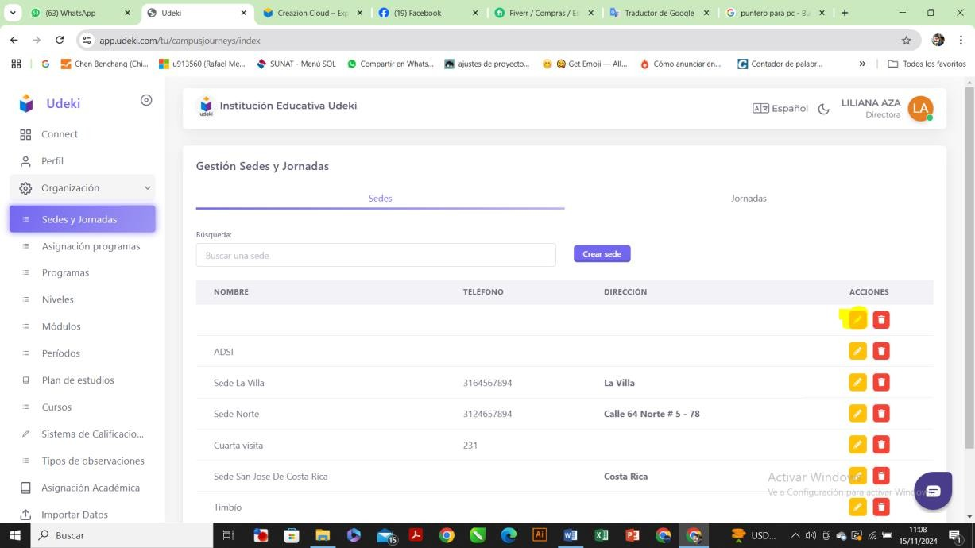

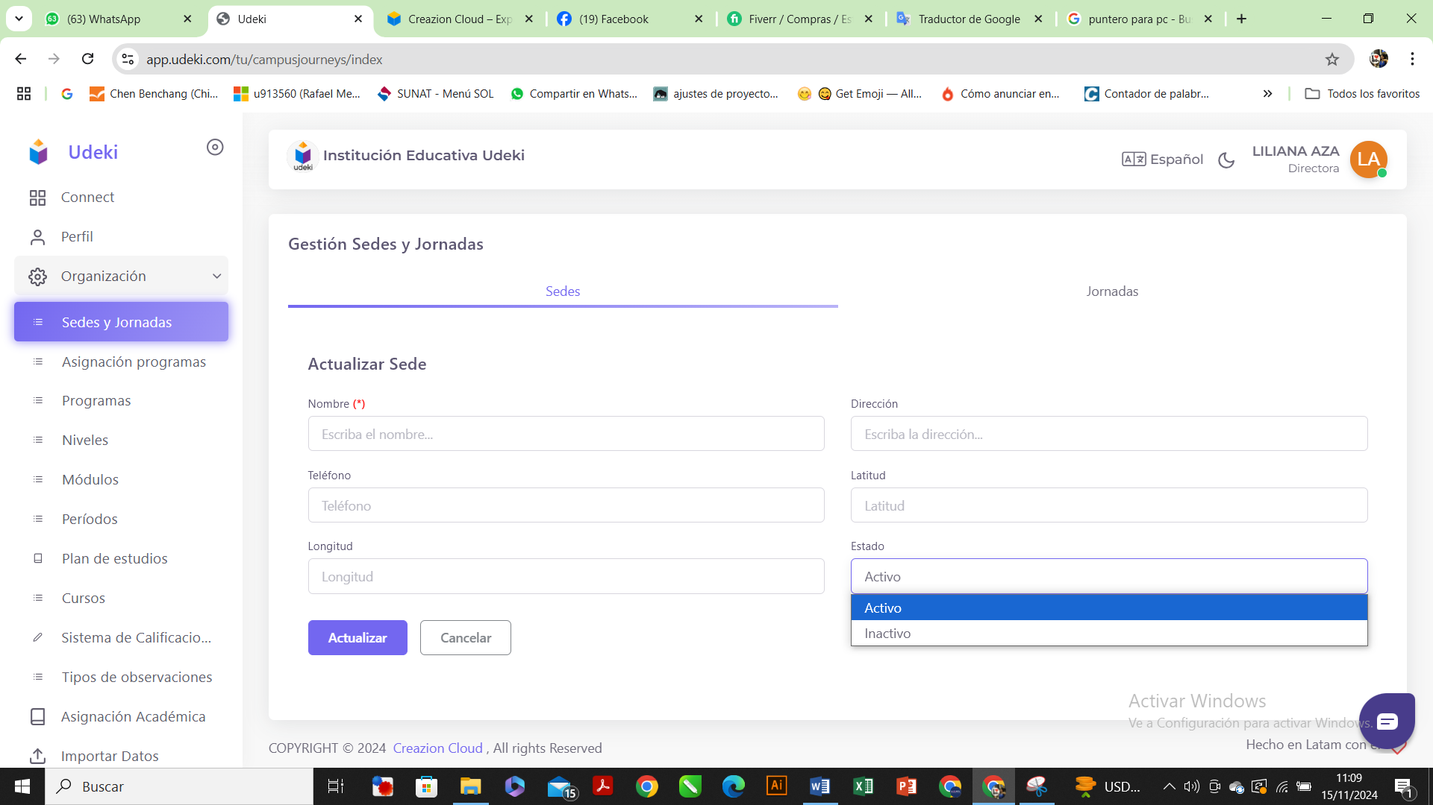

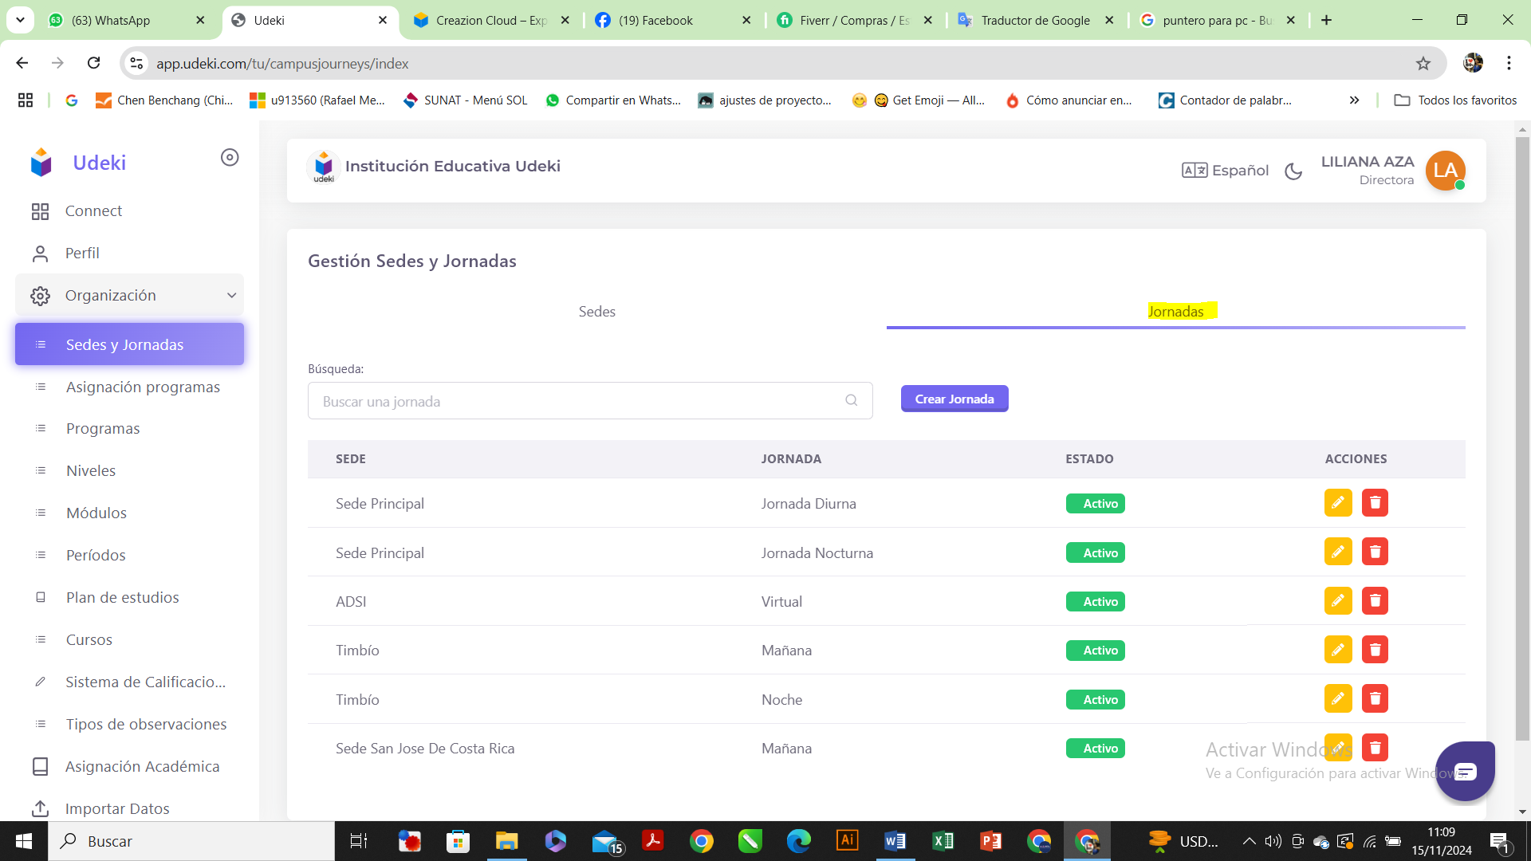

UPDATE DAY

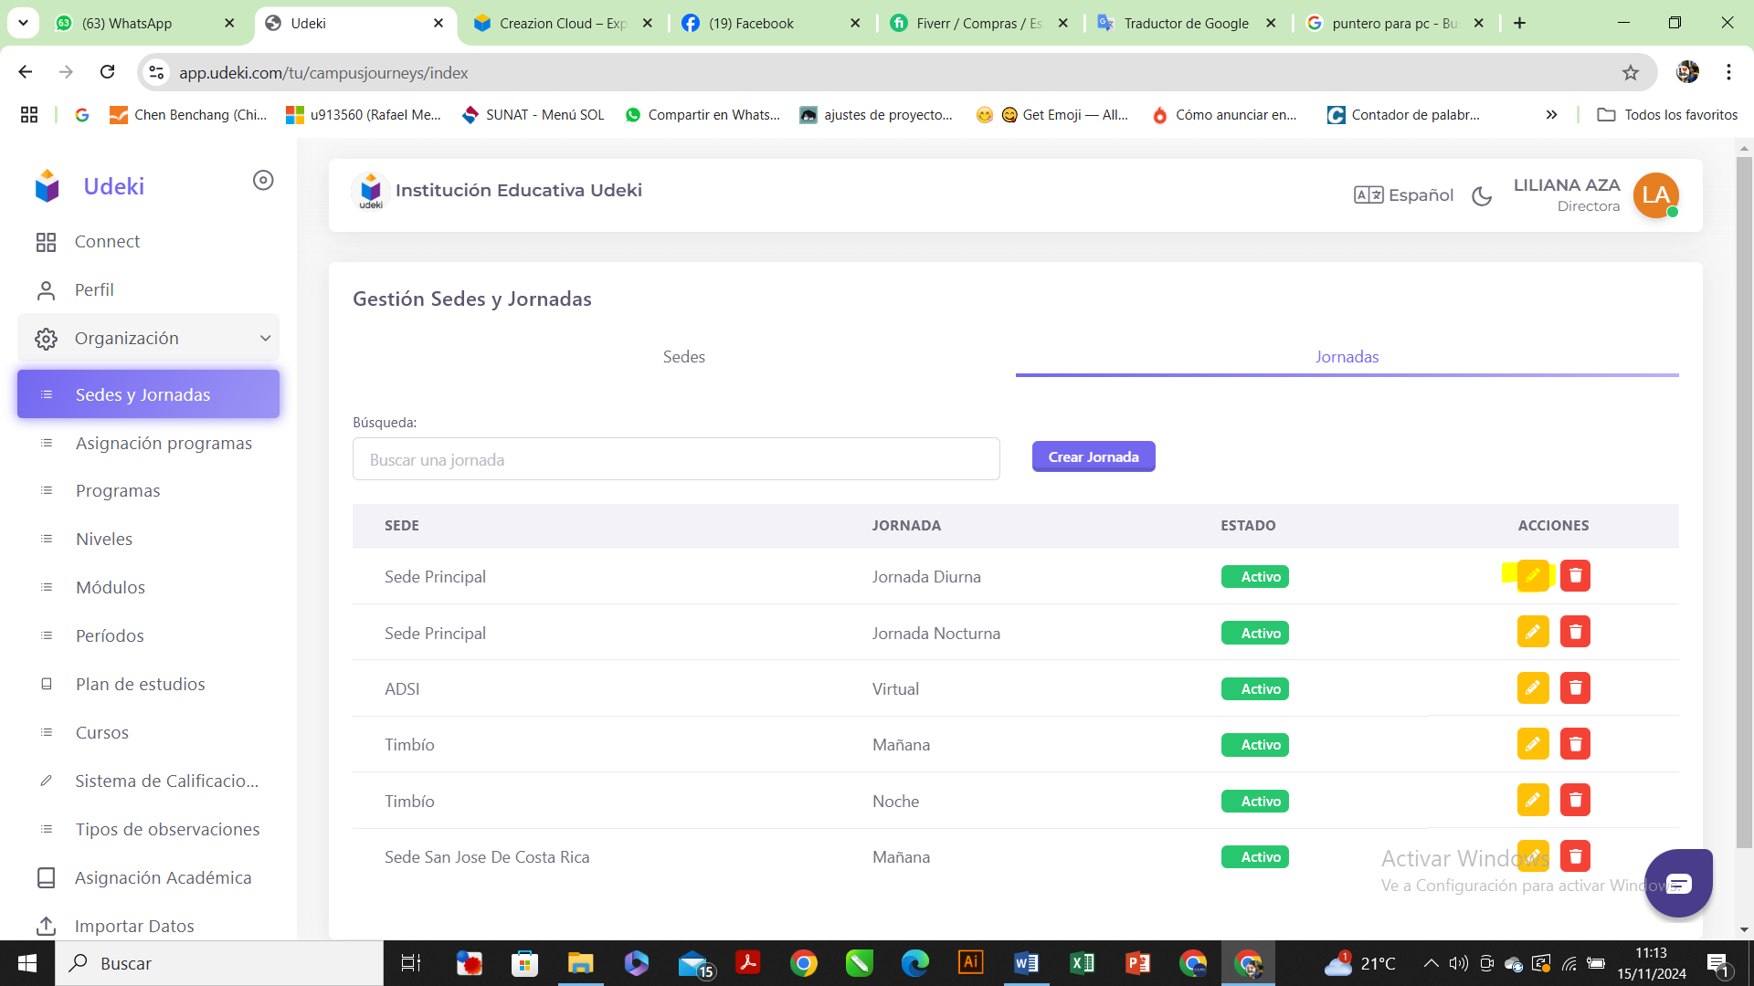

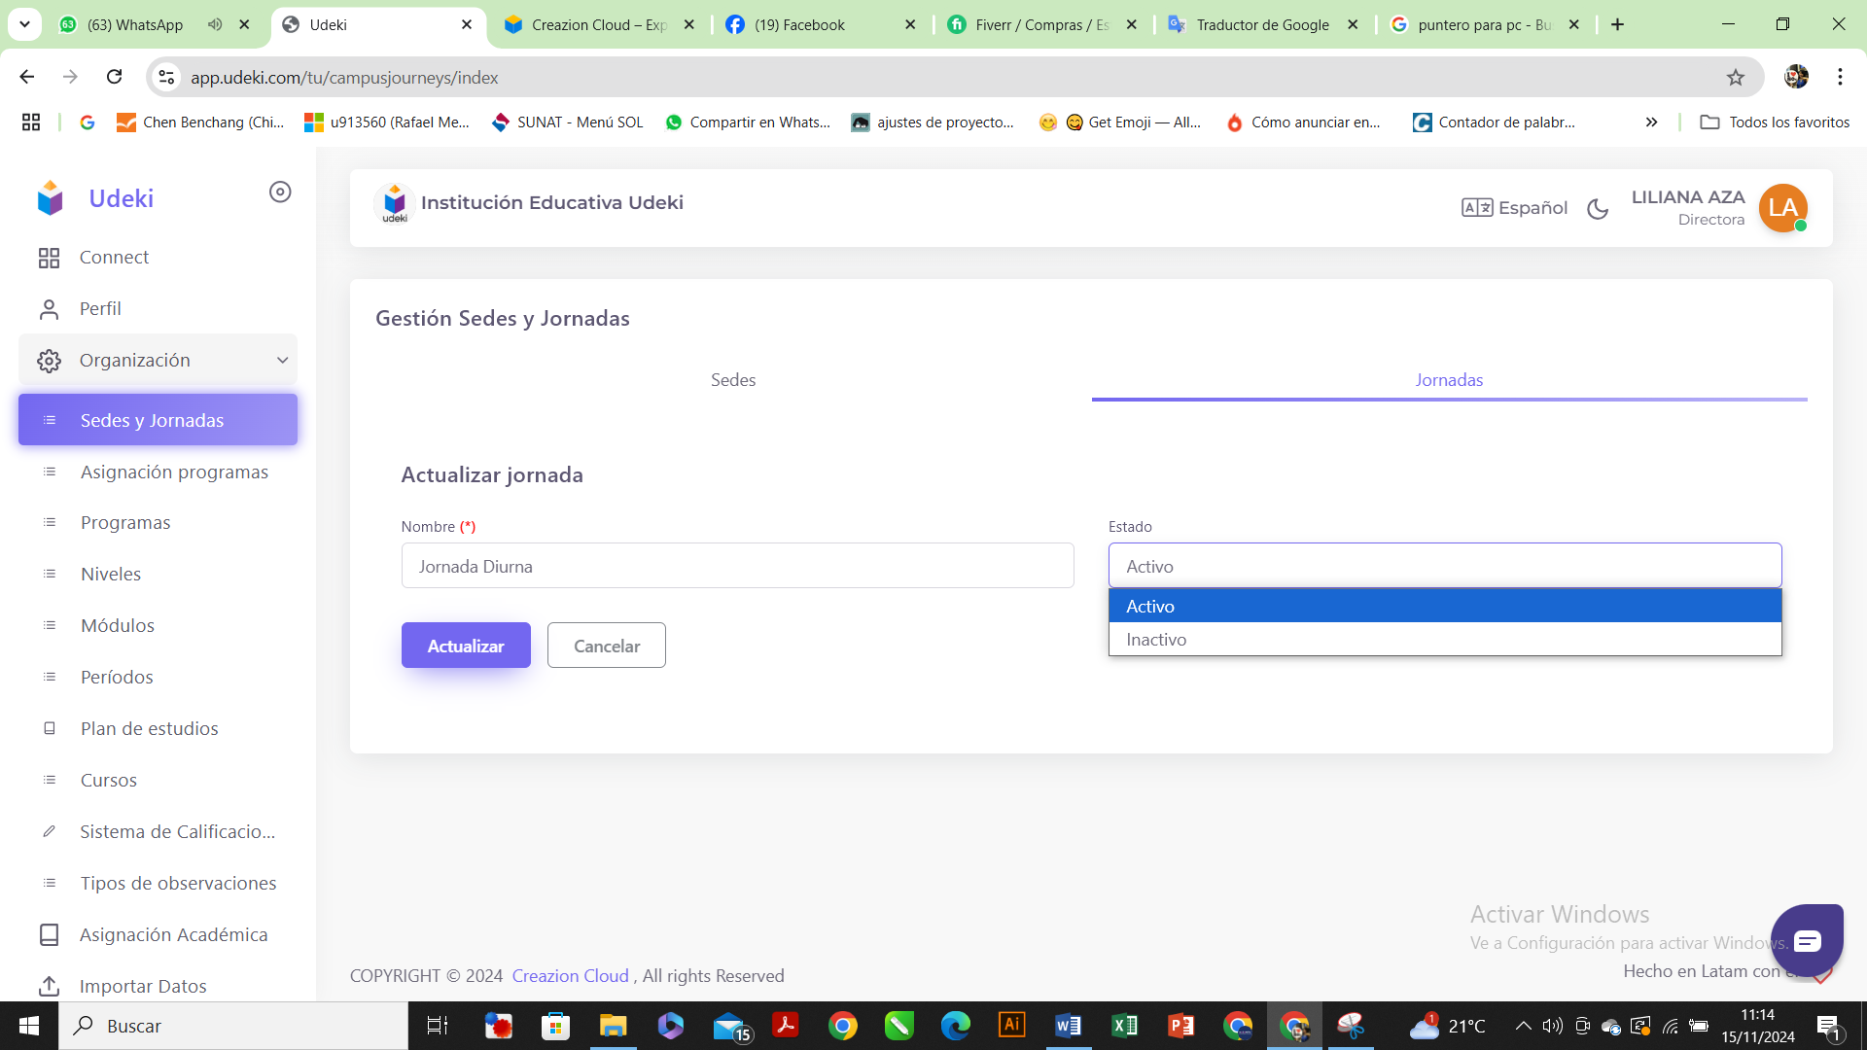

CREATE BRANCHES:

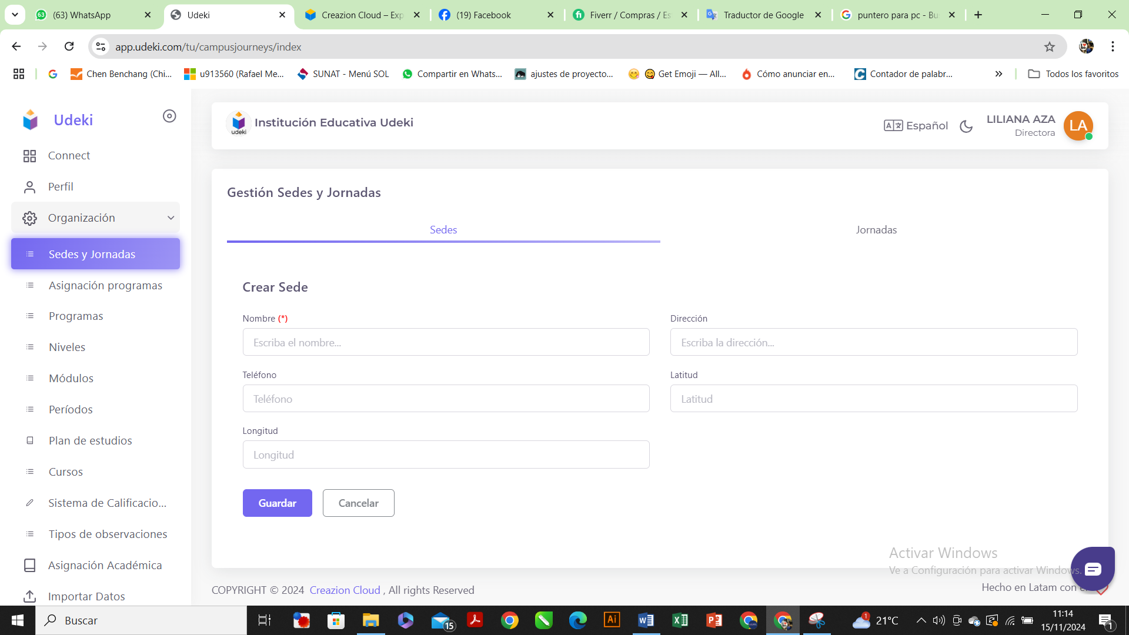

CREATE DAY:

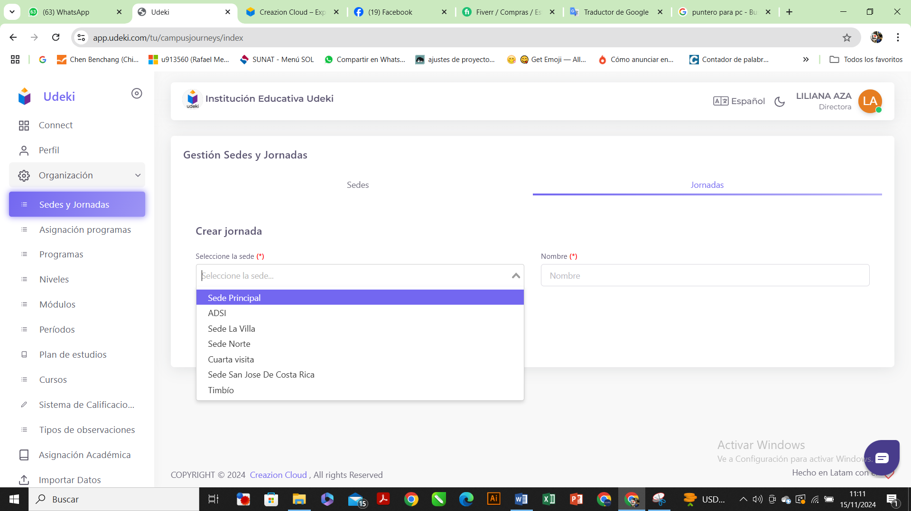

DELETE HEADQUARTERS:

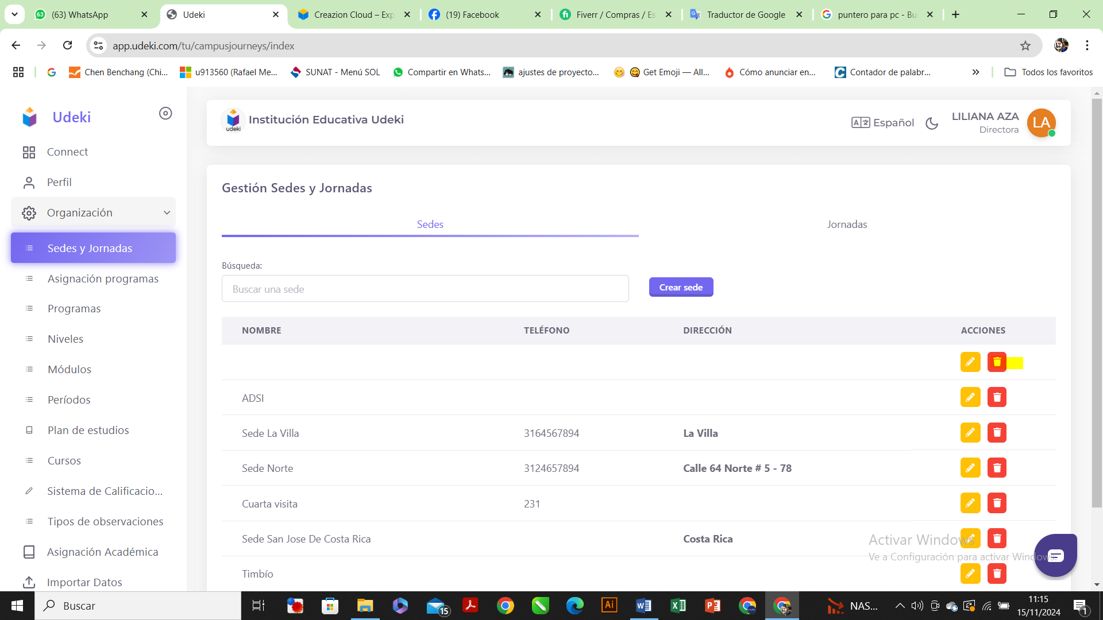

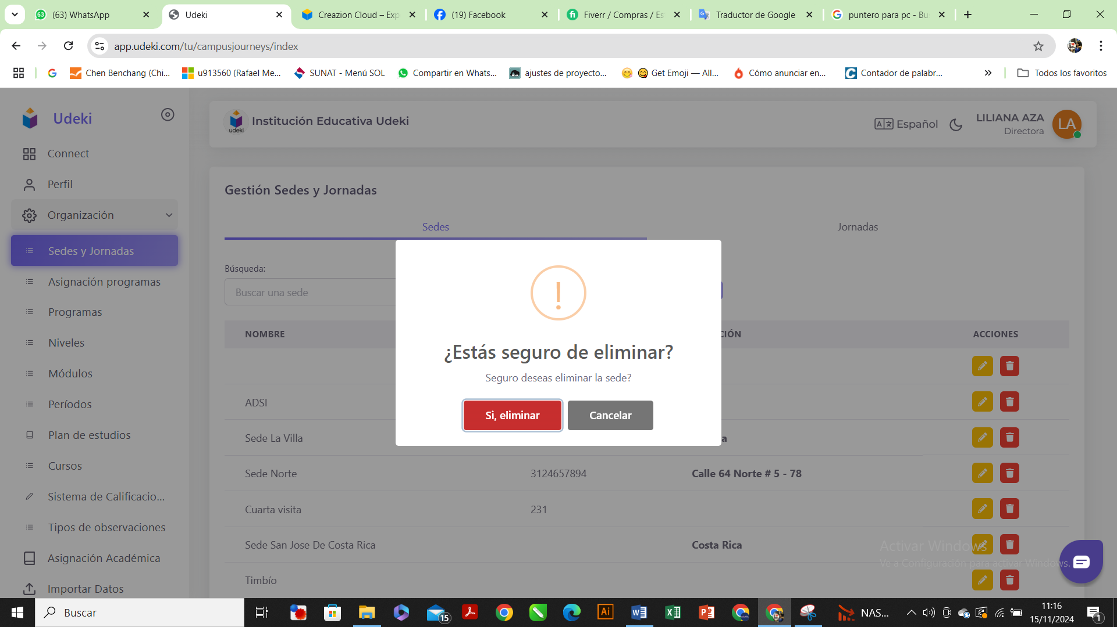

YES DELETE

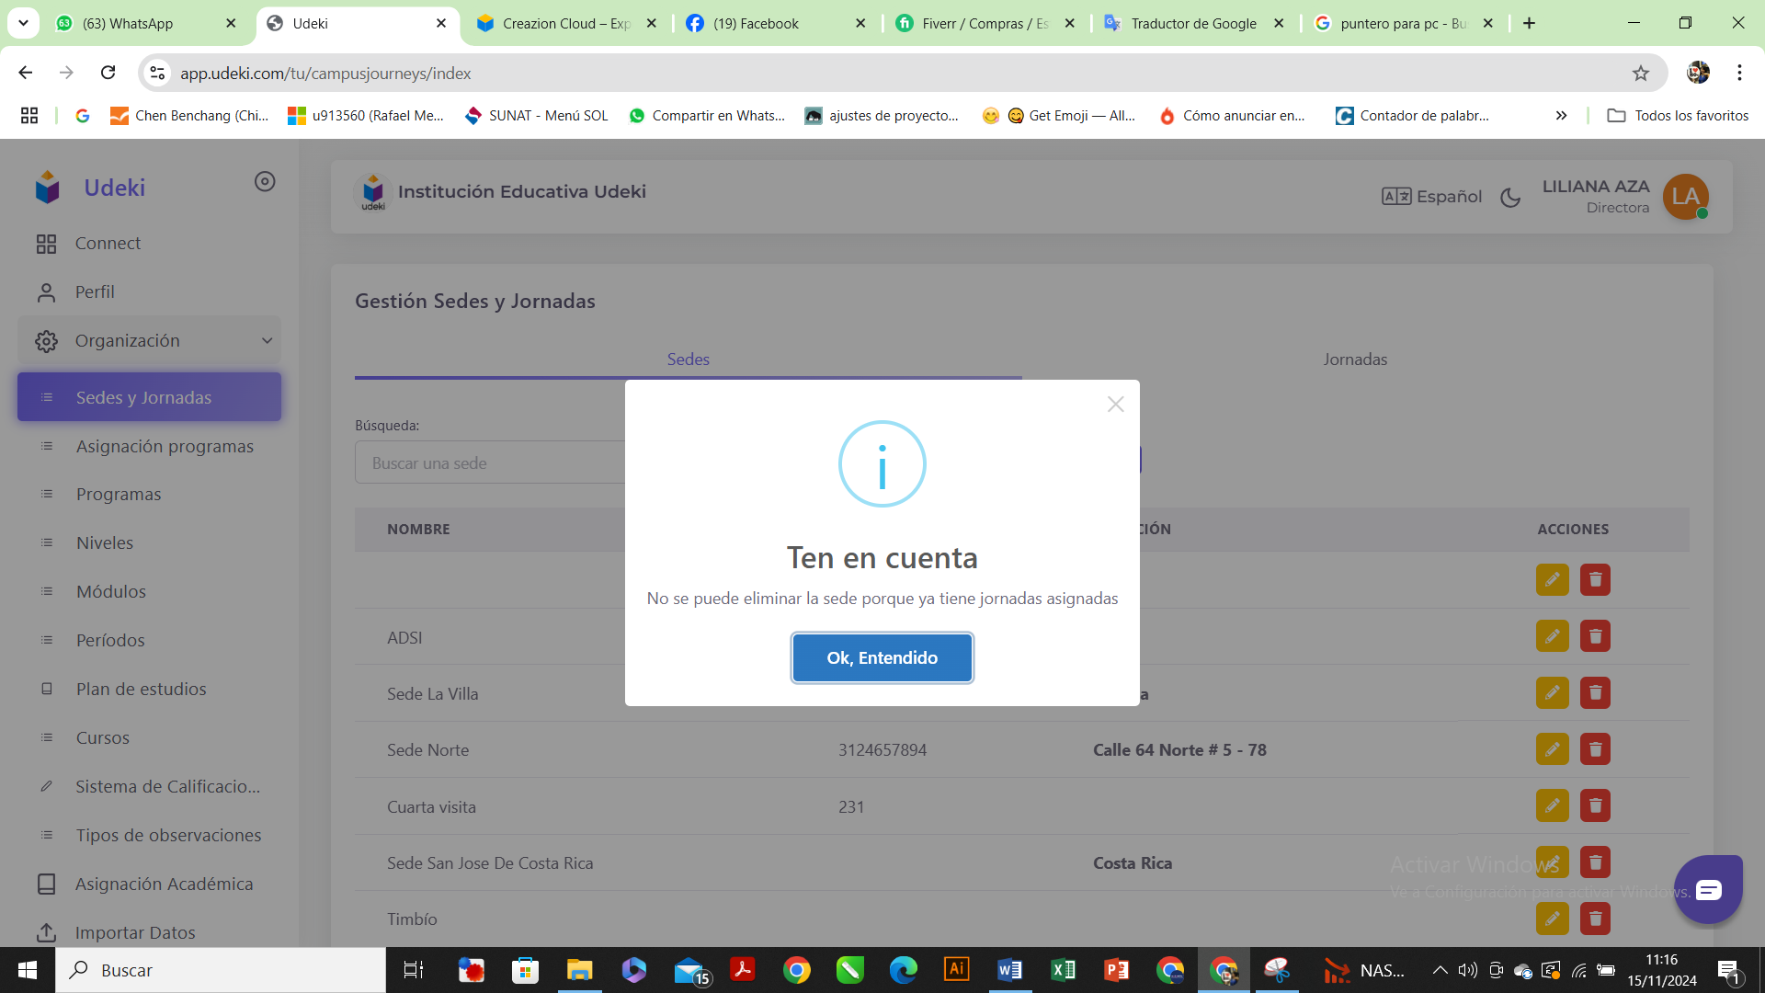

DELETE DAY

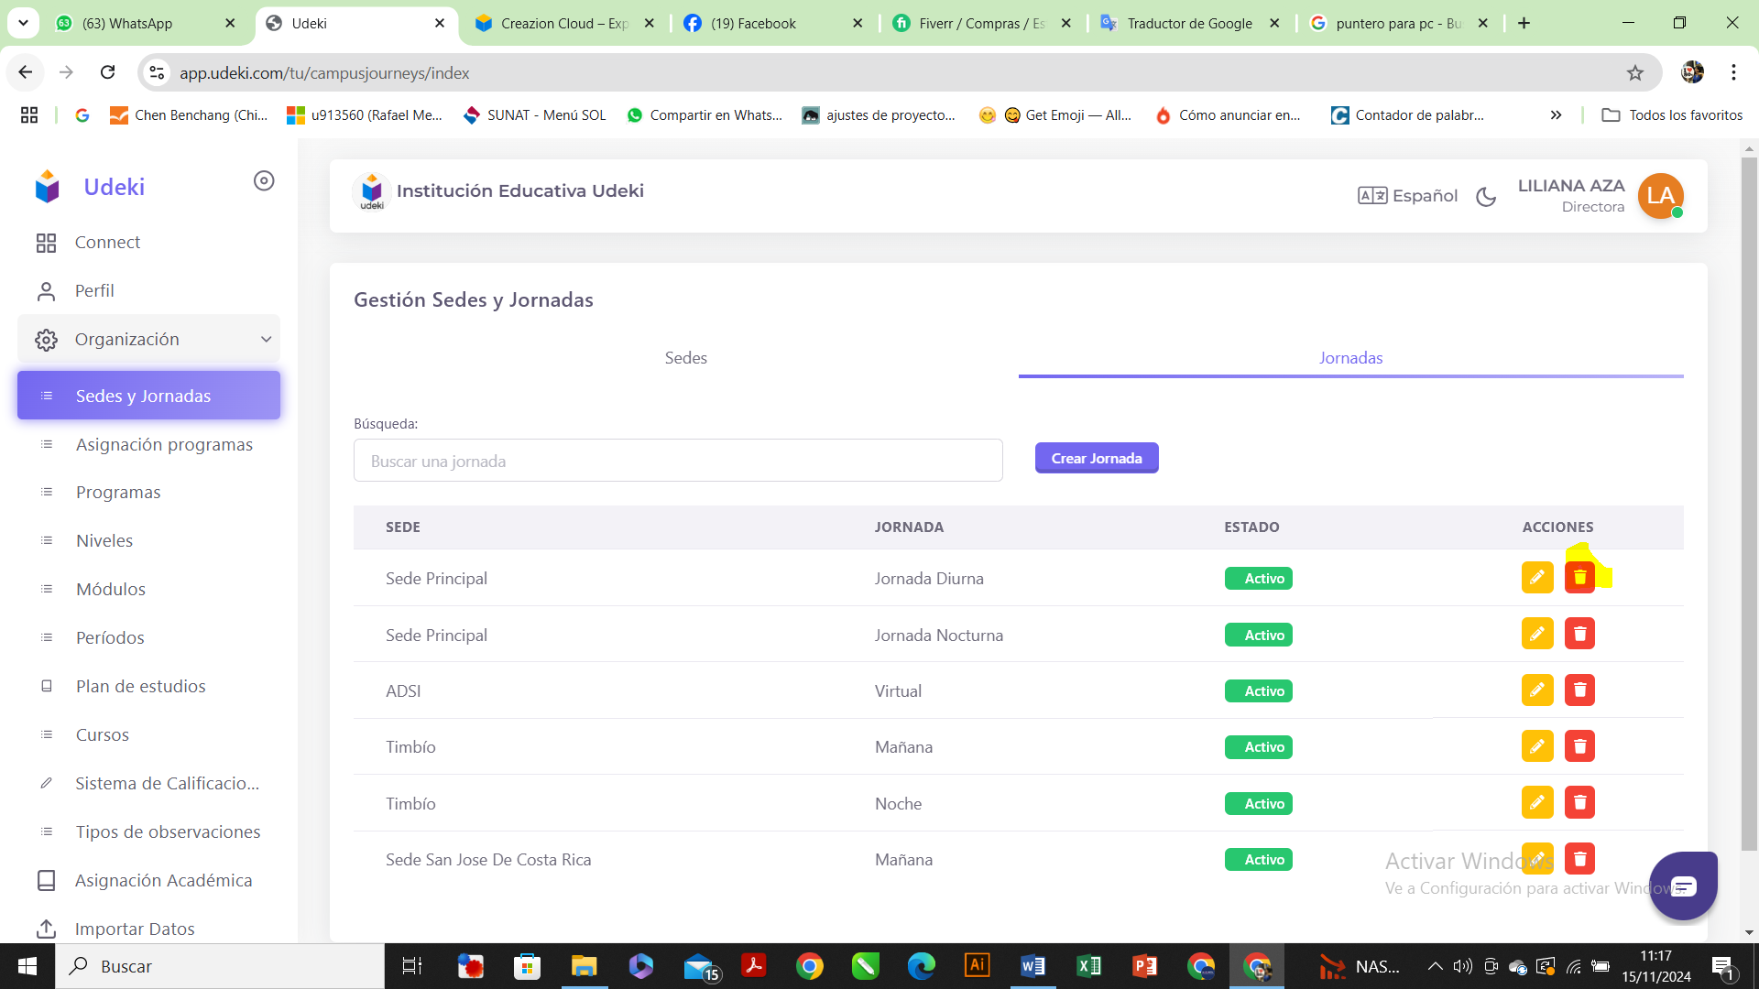

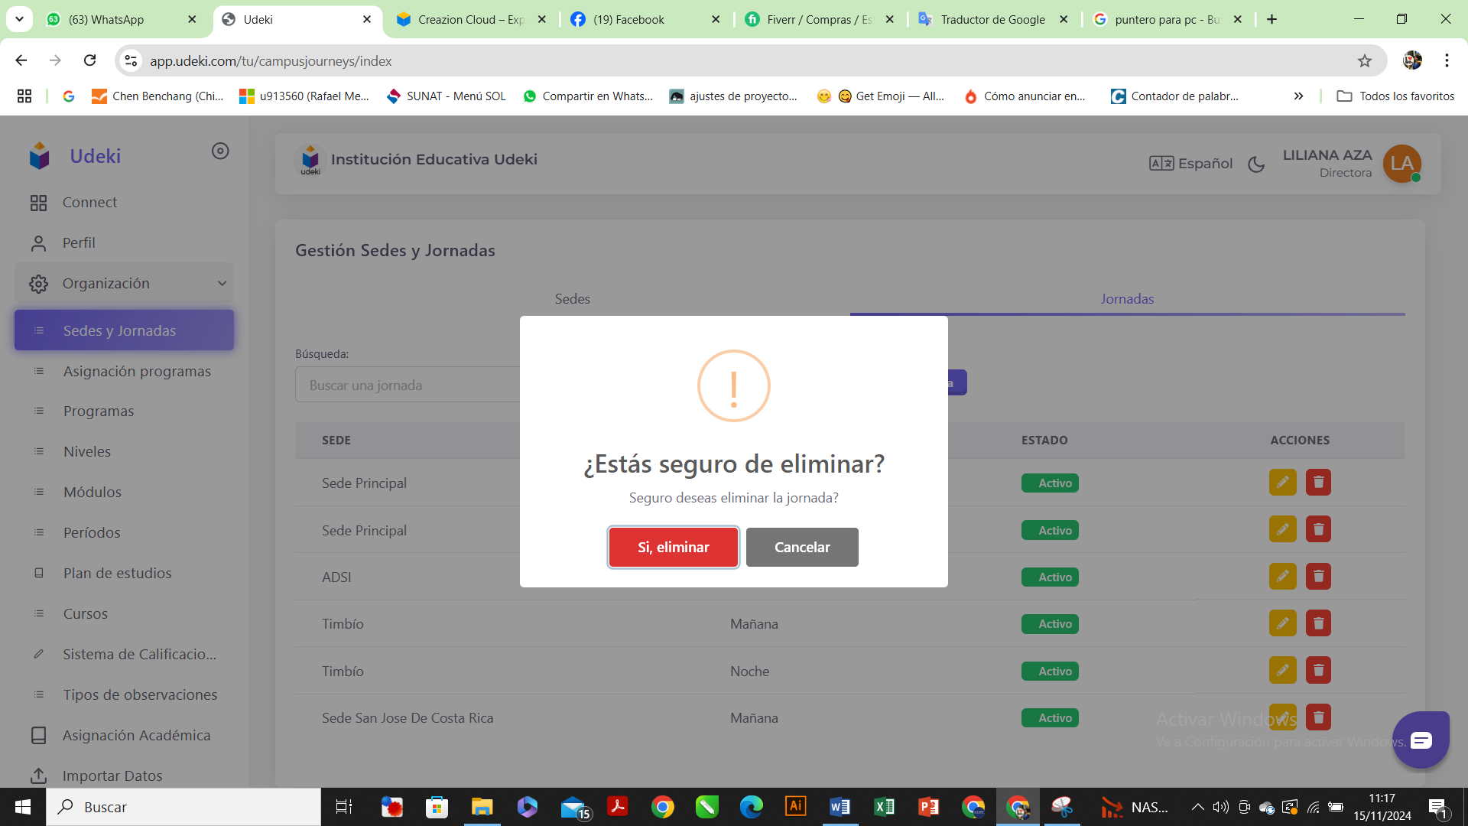

YES DELETE

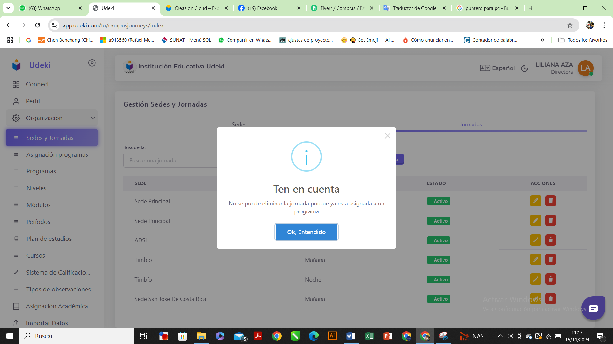

1. Import and export student data, grades, attendance and also class topics.

For export/import student data,grades, attendance its can implemented, how about class topics did you mean subject ?

UDEKI SYSTEMA: DATA IMPORT MODULE

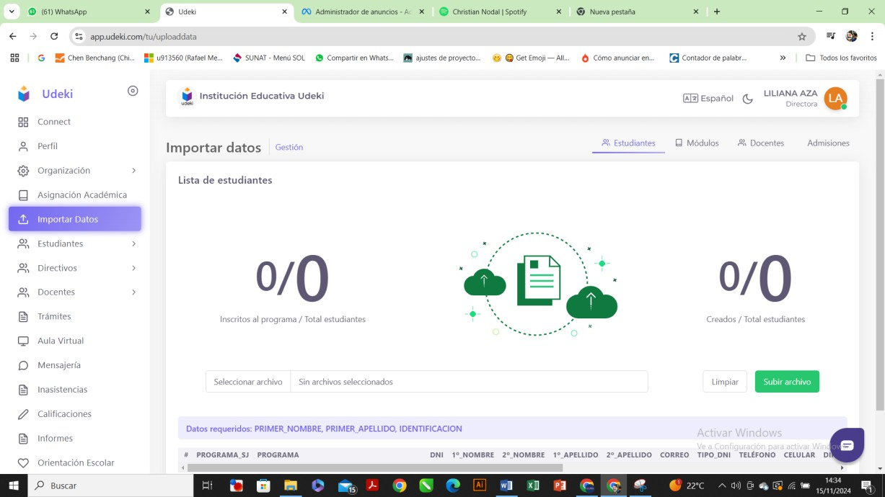

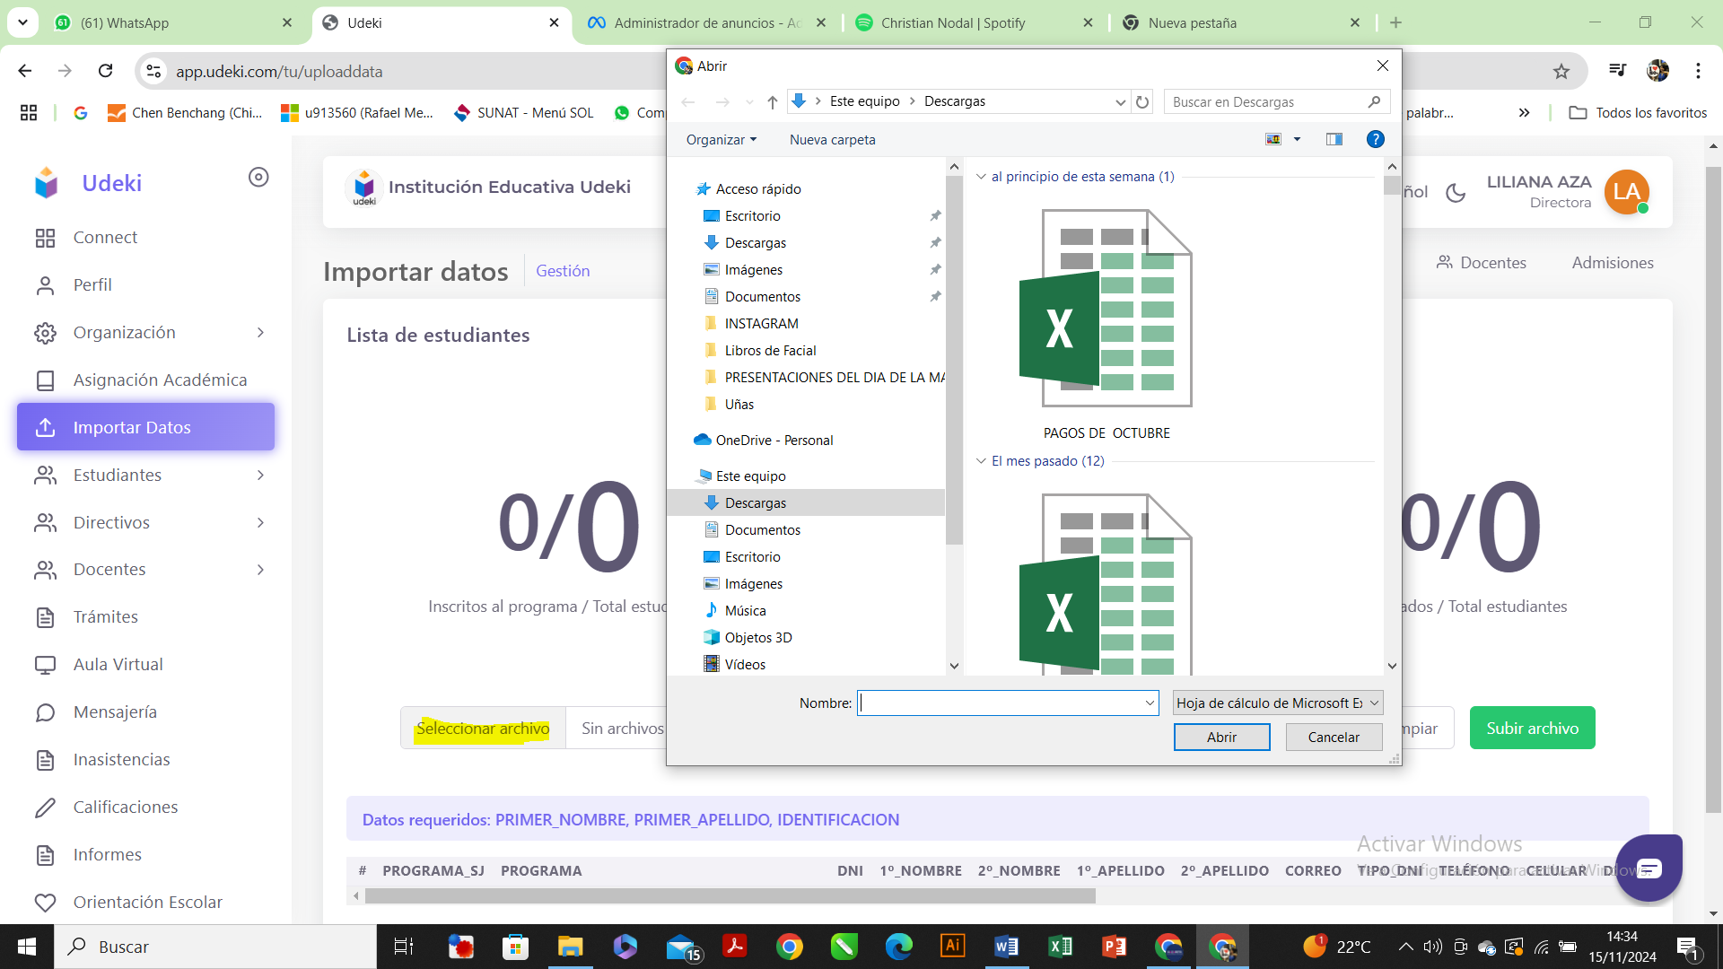

Ability to import course topics. When creating new, similar modules, we have to enter the topics manually. It would be faster to upload the topics via Excel, or to have an option to duplicate modules/courses.

Have the option to export student data, including attendance and student grades

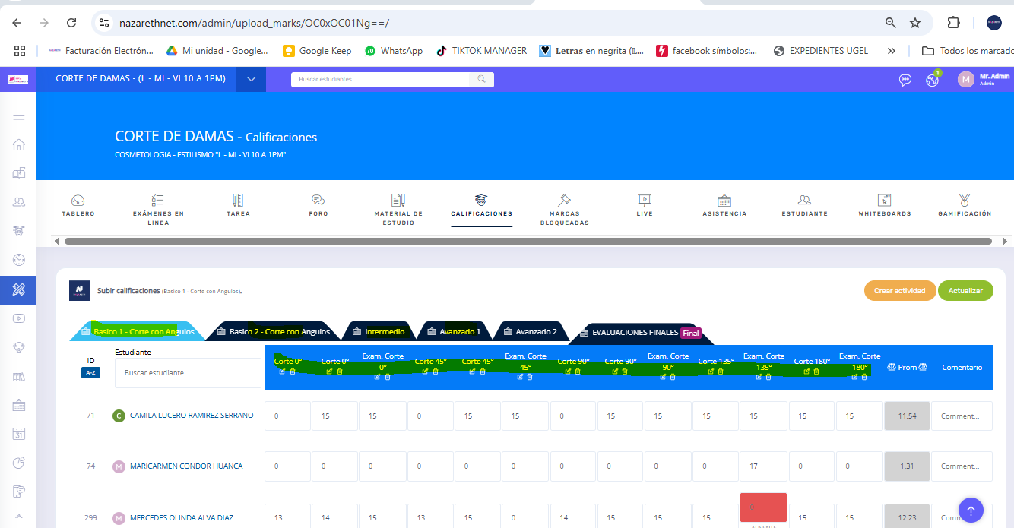

1. That there is a report of when the grade is being placed (Date and Time) and its modification history if there is one and that it can be exported.

Okay you want grade report display like attendance report(display all student and have date time modification history) and can be exported to pdf/ excel ?

Yes, Add a new report that shows the history of grades. It would be nice if it could be exported to Excel.

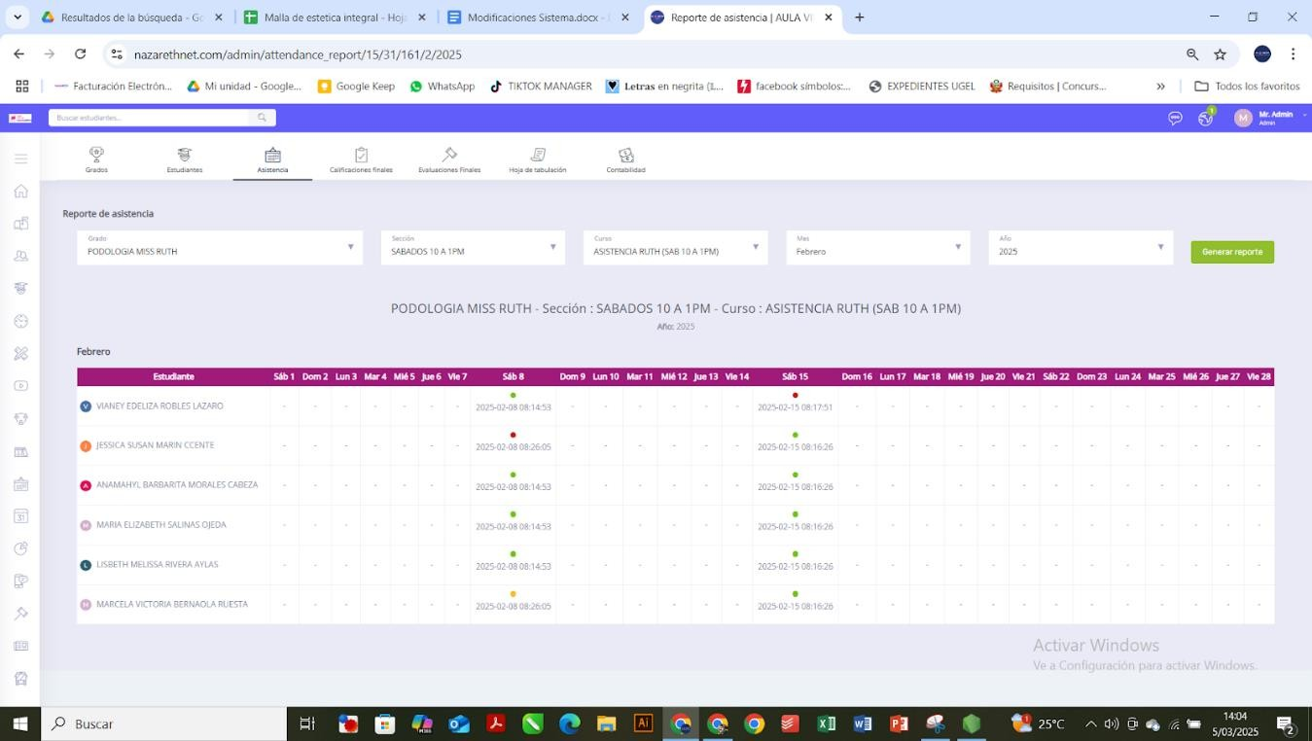

1. Allow me to publish the task without the need to mark video or audio

Clear, its can implemented

1. A module that allows me to create QR codes for certificates

Clear, its can implemented, so every certificates will automaticly generate QR where when its scanned will going to system page and provide evidence of the authenticity of the certificate

I found an example page where you enter the QR code and it validates the authenticity of the certificate.

<https://lms.becasgruporomero.pe/>

user: 70772687

password:7077287

When a student completes a course, they can download their certificate from the system. This certificate must include a code and a QR code for authenticity. The design format allows us to change or edit it by uploading the image.

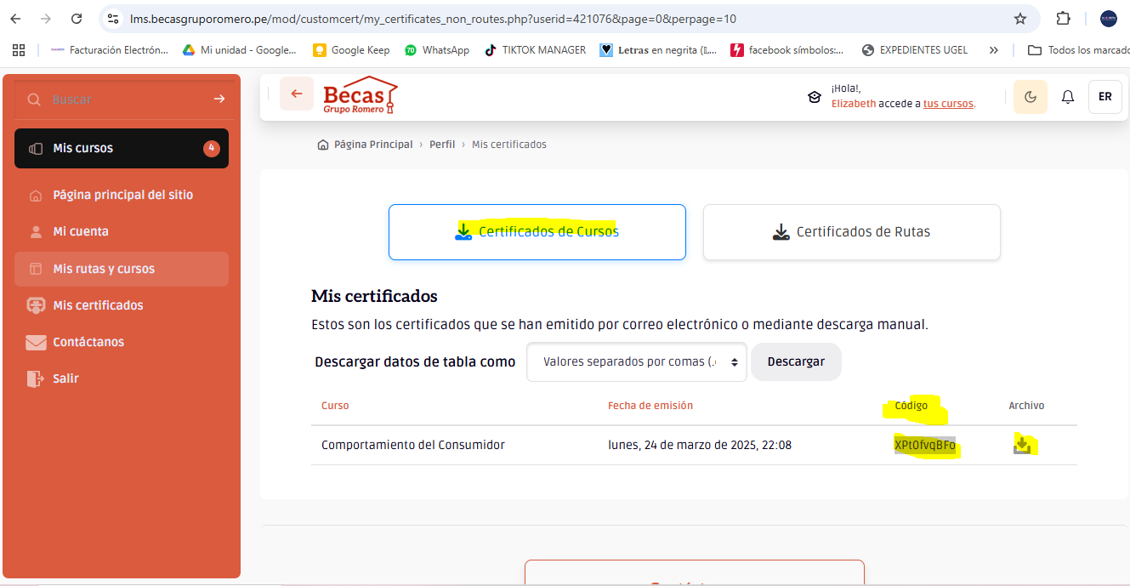

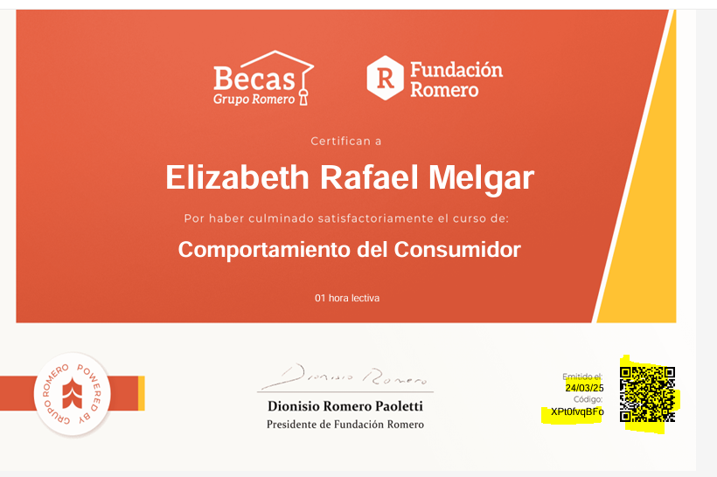

<https://lms.becasgruporomero.pe/mod/customcert/verify_certificate.php>

They have a page where you can validate the authenticity of the certificate and if you scan the QR code, it also validates the authenticity of the certificate.

